# Aim :- Data Analysis and Visualization using Advanced Excel.

## **Create a Power View Sheet**

Make sure Power View add-in is enabled in Excel 2013.

**Step 1 −** Click on the File menu and then Click on Options.

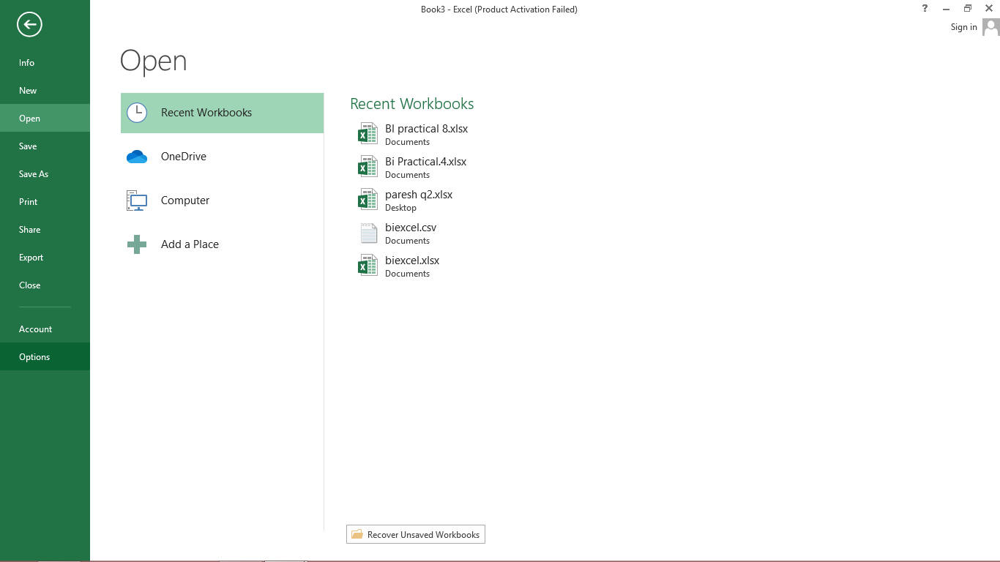

The Excel Options window appears.

**Step 2 −** Click on Add-Ins.

**Step 3** − In the Manage box, click the drop-down arrow and select Excel Add-ins.

**Step 4 −** All the available Add-ins will be displayed. If Power View Add-in is enabled, it appears in Active Application Add-ins.

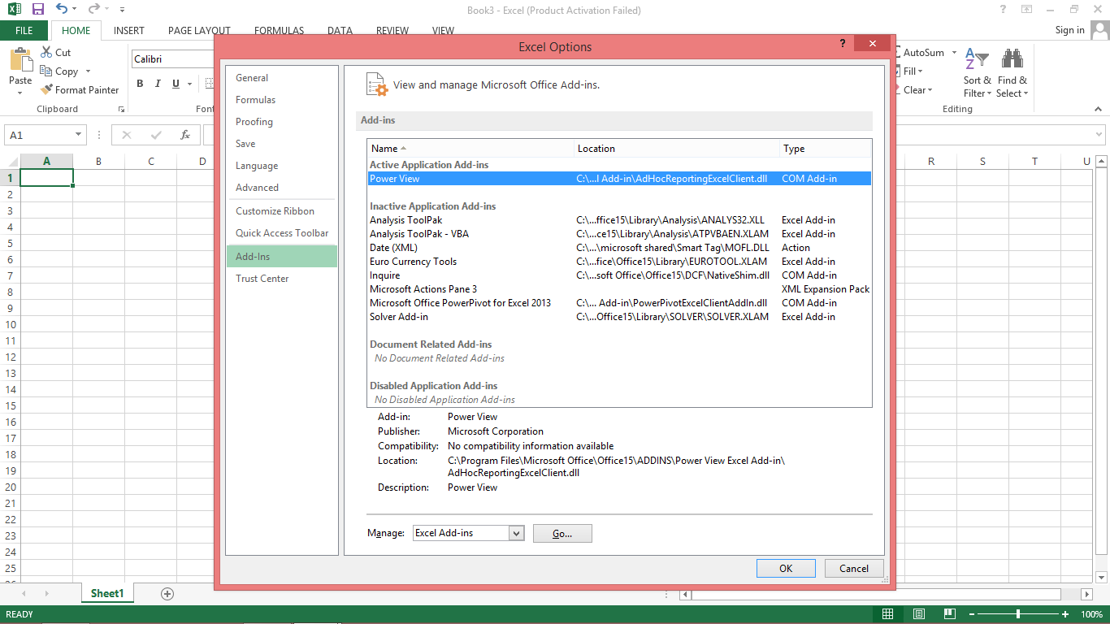

If it does not appear, follow these steps –

**Step 1** − In the Excel Options Window, Click on Add-In.

[**Step 2** − In the Manage box, click the drop-down arrow and select COM Add-ins](https://e-next.in/)

[**Step 3** − Click on the Go button. A COM Add-Ins Dialog Box appears.](https://e-next.in/)

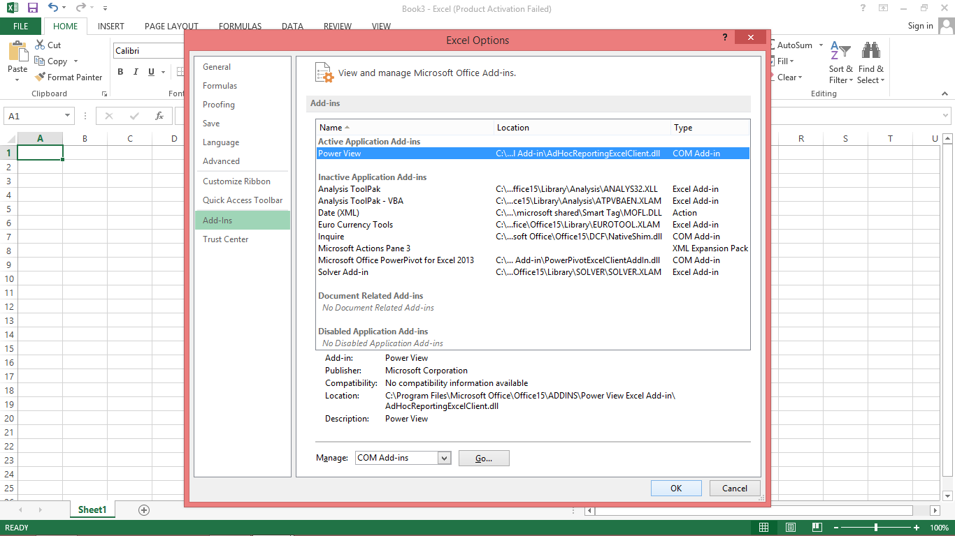

[**Step 4** − Check the Power View Check Box.](https://e-next.in/)

[**Step 5** − Click OK.](https://e-next.in/)

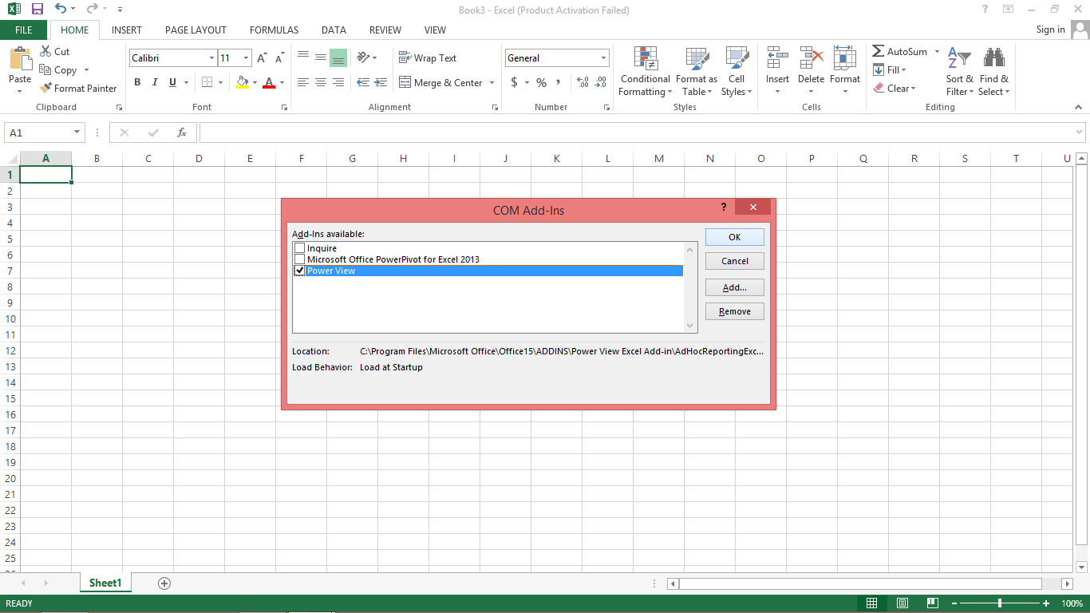

Now, first add the data tables from Form Access.

**Step 1 −** Open a new blank Workbook in Excel.

**Step 2 −** Click on the DATA tab.

**Step 3 −** In the Get External Data group, click on the option From Access. The Select Data

Source dialog box opens.

**Step 4 −** Select Events3_Data.mdb, Events Access Database file.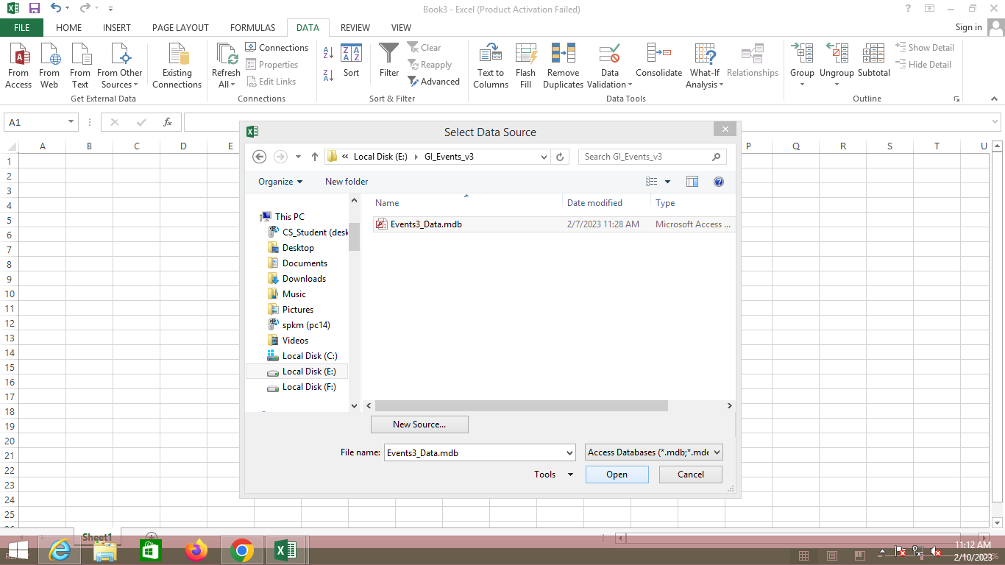

**Step 5** − The Select Table window, displaying all the tables found in the database, appears.

**Step 6** − Tables in a database are similar to the tables in Excel. Check the ‘Enable selection of multiple tables’ box, and select all tables. Then click OK.

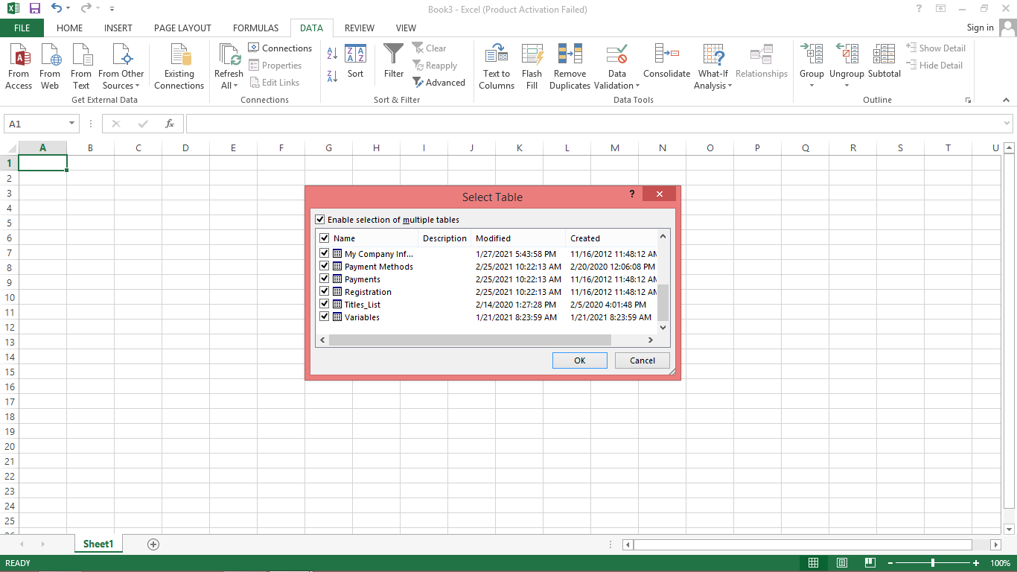

**Step 7** − The Import Data window appears. Select the Table option. This option imports the tables into Excel.

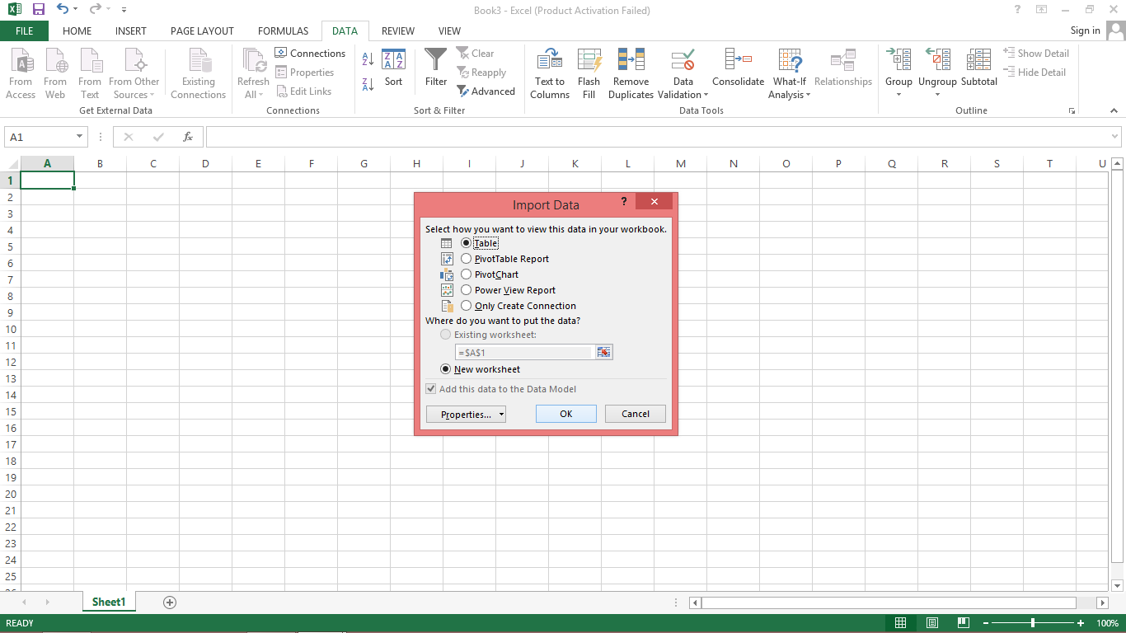

The data is imported

Now, you are ready to create the Power View sheet.

**Step 1 −** Click on the Data Table.

**Step 2 −** Click on Insert tab.

**Step 3 −** Click on Power View in Reports Group.

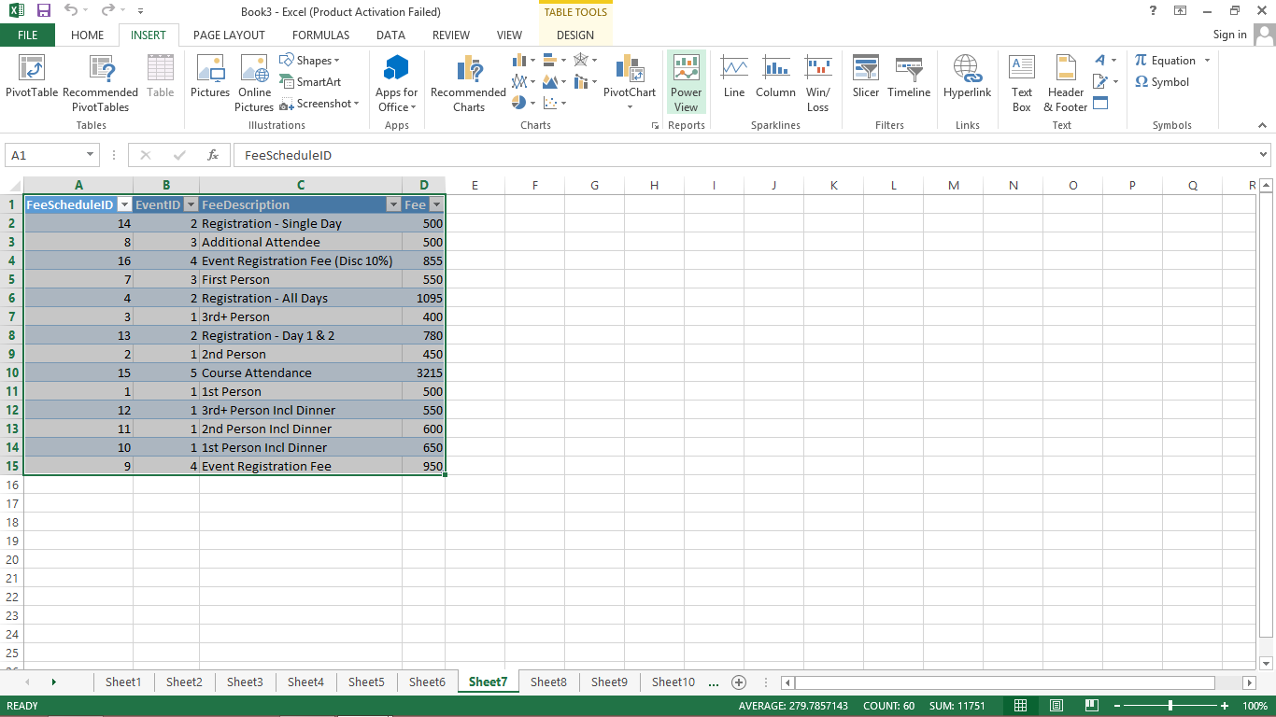

[An Opening Power View window opens, showing the progress of Working on opening Power View sheet.](https://e-next.in/)

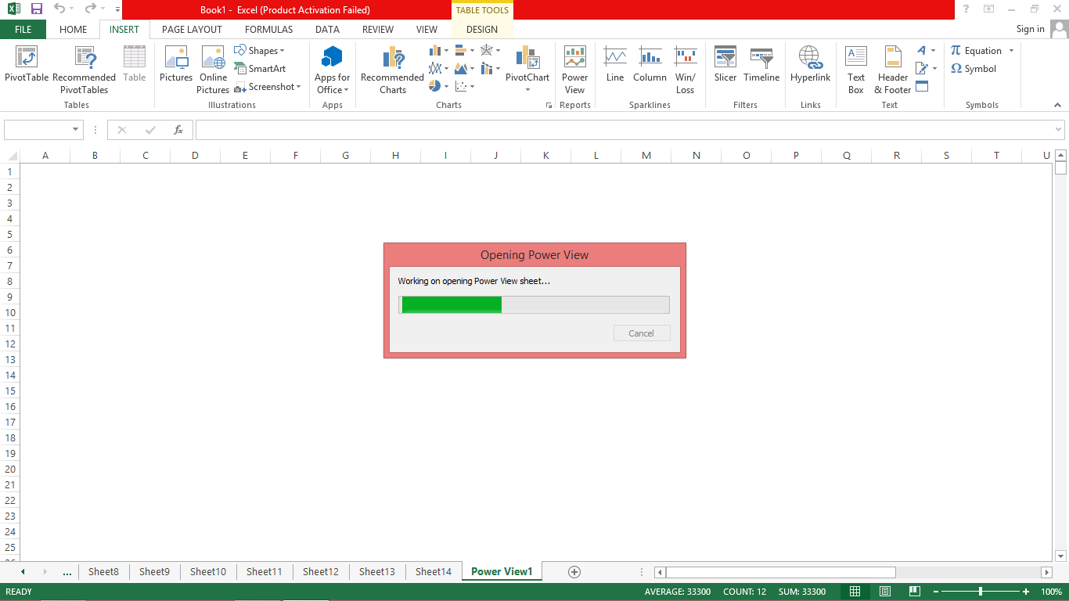

The Power View sheet is created for you and added to your Workbook with the Power View. On the Right-side of the Power View, you find the Power View Fields. Under the Power View Fields you will find Areas.

In the Ribbon, if you click on Design tab, you will find various Visualization options.

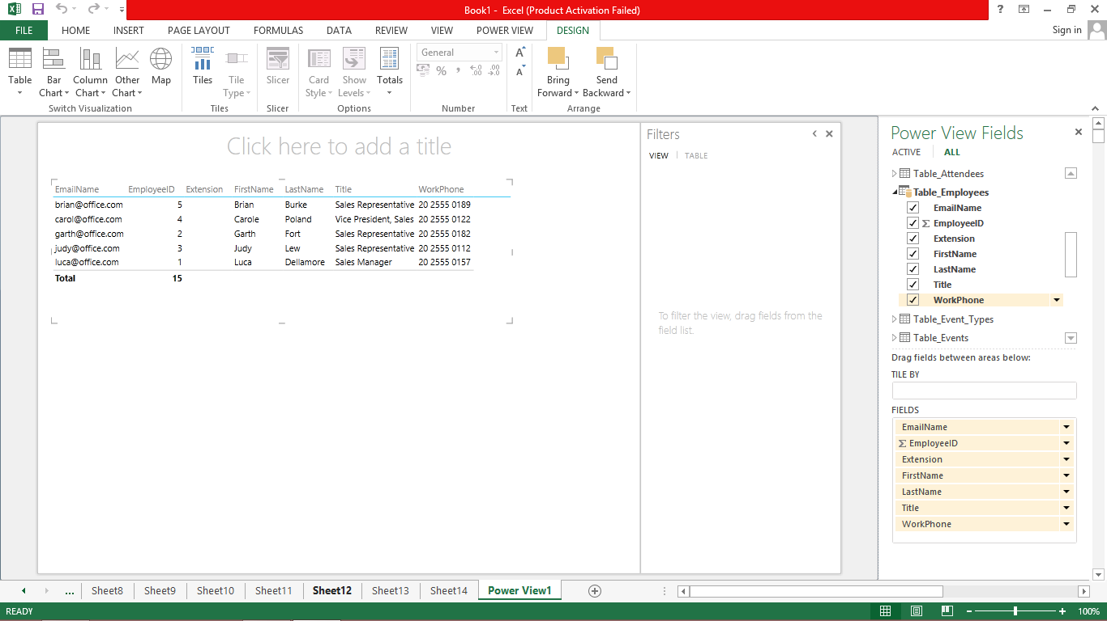

## Create Charts and other Visualizations

For every visualization you want to create, you start on a Power View sheet by creating a [table, which you then easily convert to other visualizations, to find one that best illustrates your Data.](https://e-next.in/)

[**Step 1** − Under the Power View Fields, select the fields you want to visualize.](https://e-next.in/)

[**Step 2** − By default, the Table View will be displayed. As you move across the Table, on the top-right corner, you find two symbols – Filters and Pop out.](https://e-next.in/)

[**Step 3** − Click on the Filters symbol. The filters will be displayed on the right side. Filters has two tabs. View tab to filter all visualizations in this View and Table tab to filter the](https://e-next.in/) specific values in this table only.

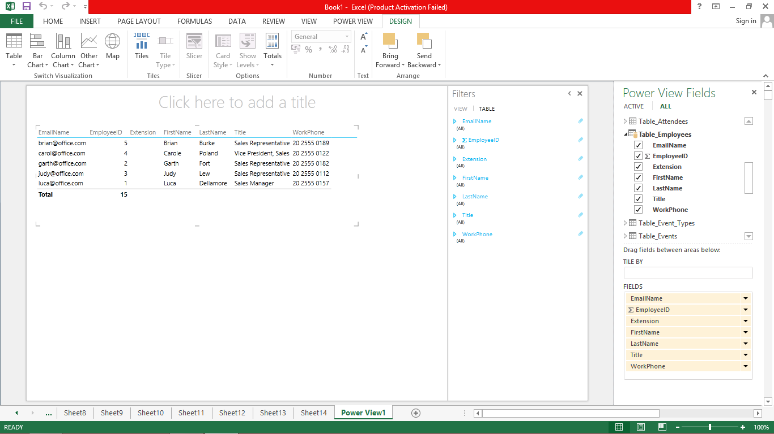

## **Visualization – Matrix**

## **Collapse and Expand the Display**

**Step 1** − Click on the DESIGN tab.

**Step 2** − Click on Table in the Switch Visualization Group.

**Step 3** − Click on Matrix.

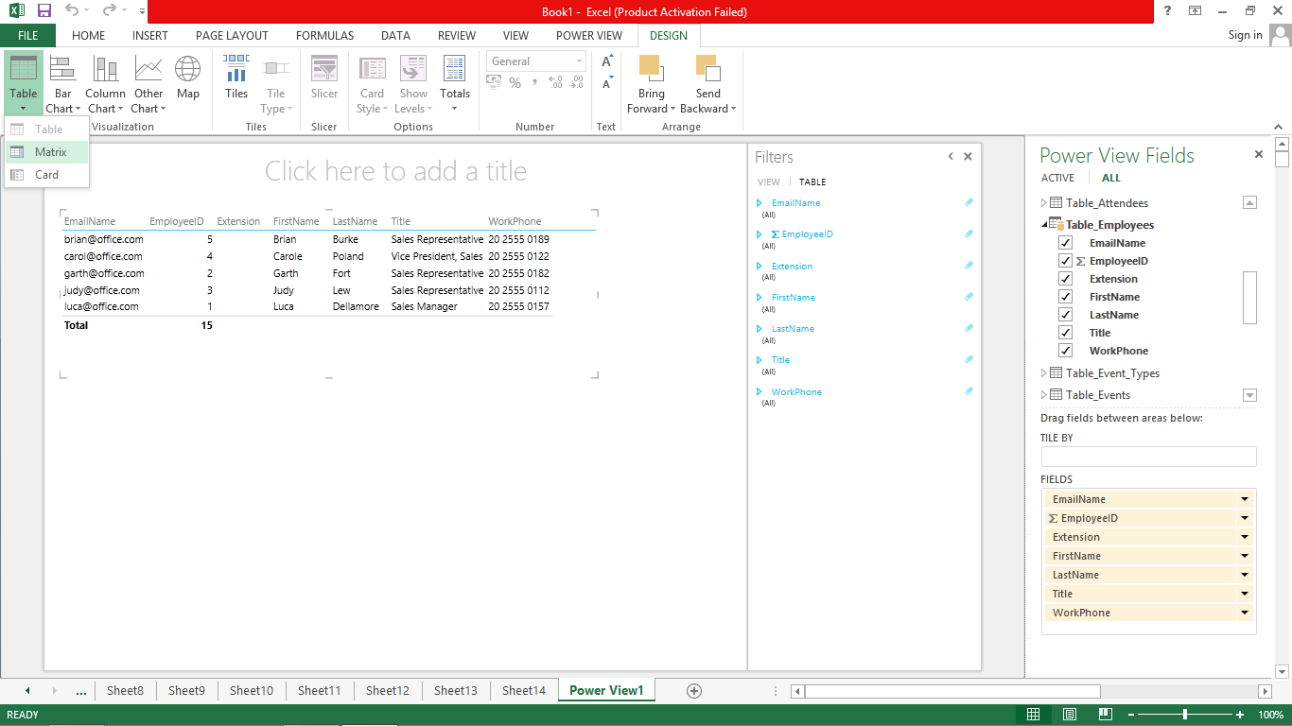

The Matrix Visualization appears.

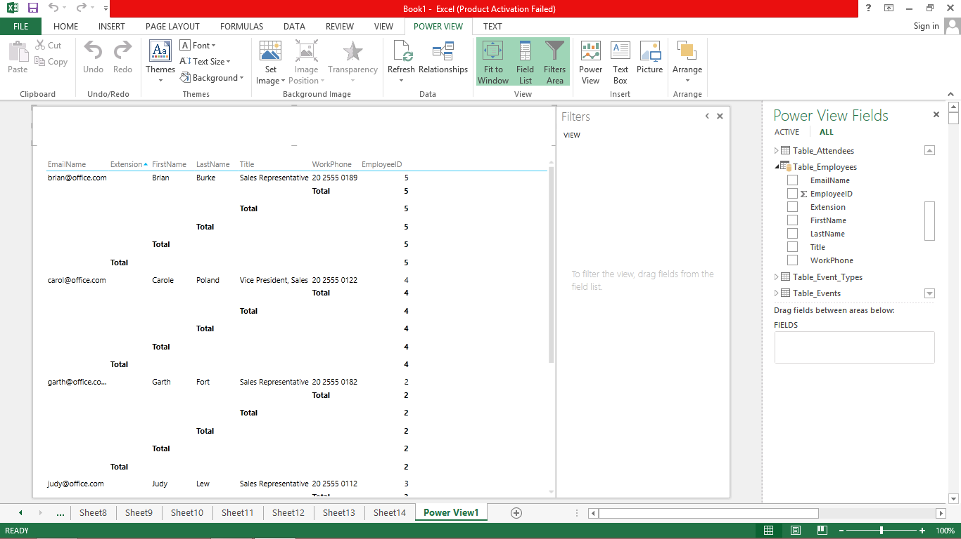

### **Visualization – Card**

You can convert a Table to a series of Cards that display the data from each row in the table [laid out in a Card format, like an index Card.](https://e-next.in/)

[**Step 1** − Click on the DESIGN tab.](https://e-next.in/)

[**Step 2** − Click on Table in the Switch Visualization Group.](https://e-next.in/)

[**Step 3** − Click on Card.](https://e-next.in/)

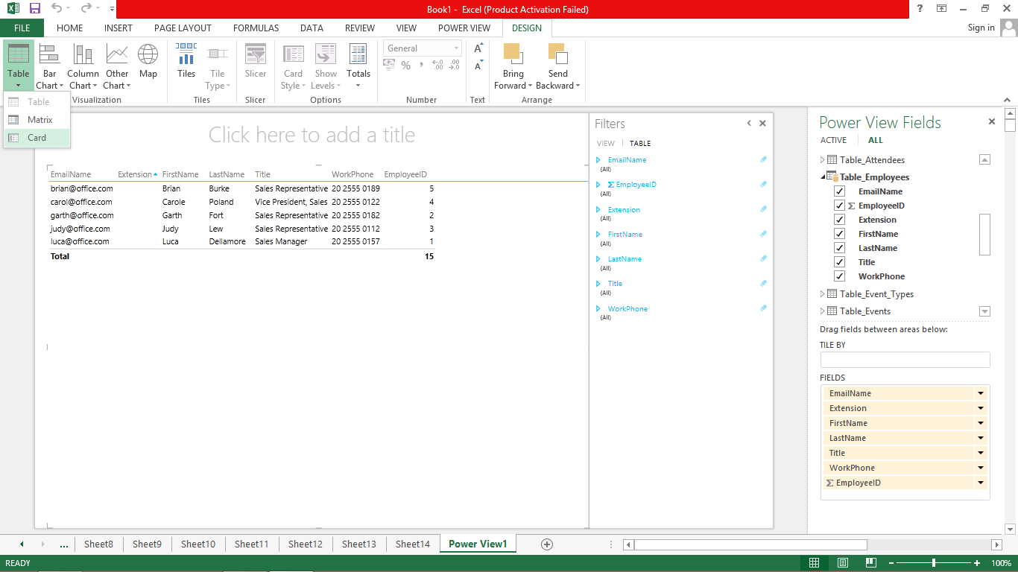

The Card Visualization appears.

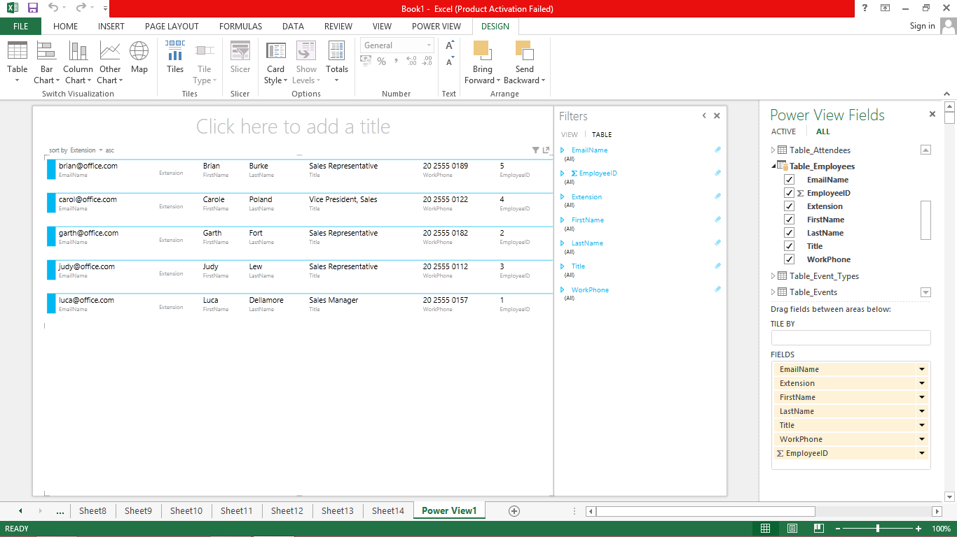

### **Visualization – Charts**

### 

**Step 1** − Create a Table Visualization from Attendees data.

**Step 2** − Create a Table Visualization for two Columns, AttendeeFirstName and AttendeeID.

**Step 3** − Create the same Table Visualization below.

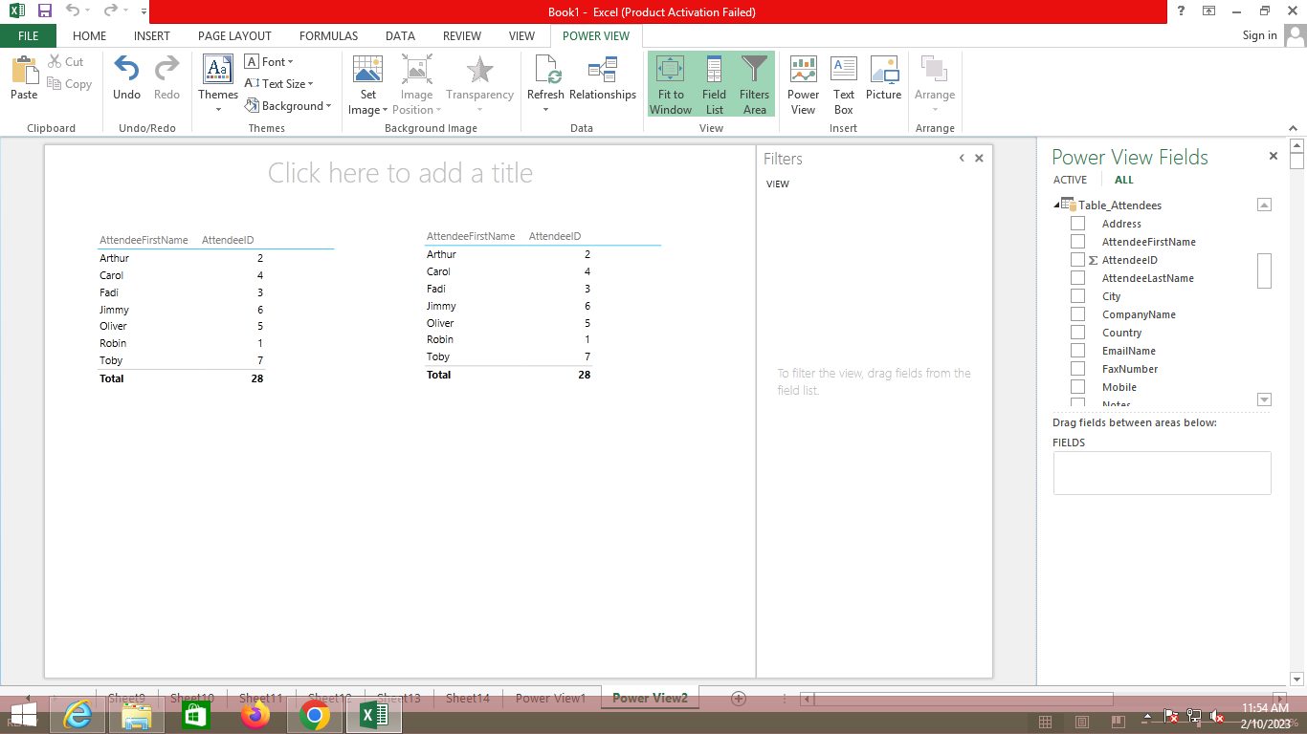

Line Charts distribute category data evenly along a horizontal (category) axis, and all numerical value data along a vertical (value) axis.

**Step 4** − Click on the Table Visualization below.

**Step 5** − Click on Other Chart in the Switch Visualization group.

[**Step 6** − Click on Line.](https://e-next.in/)

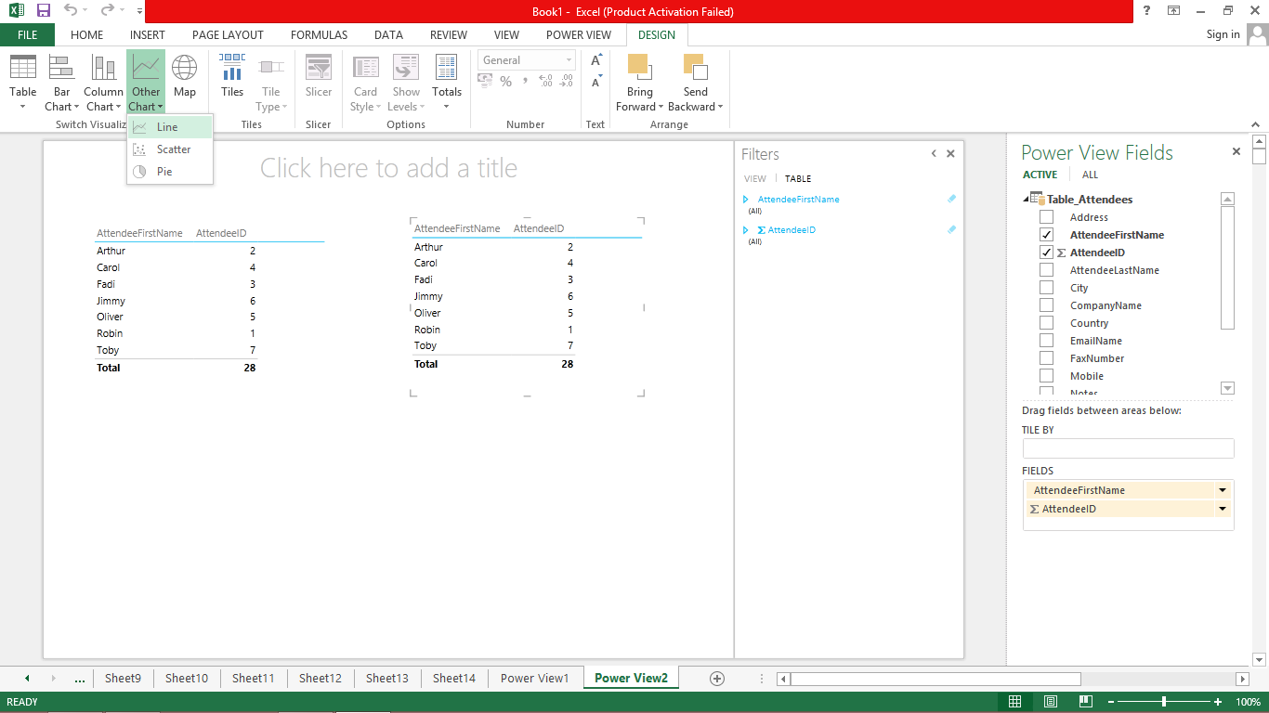

The Table Visualization converts into Line Chart Visualization.

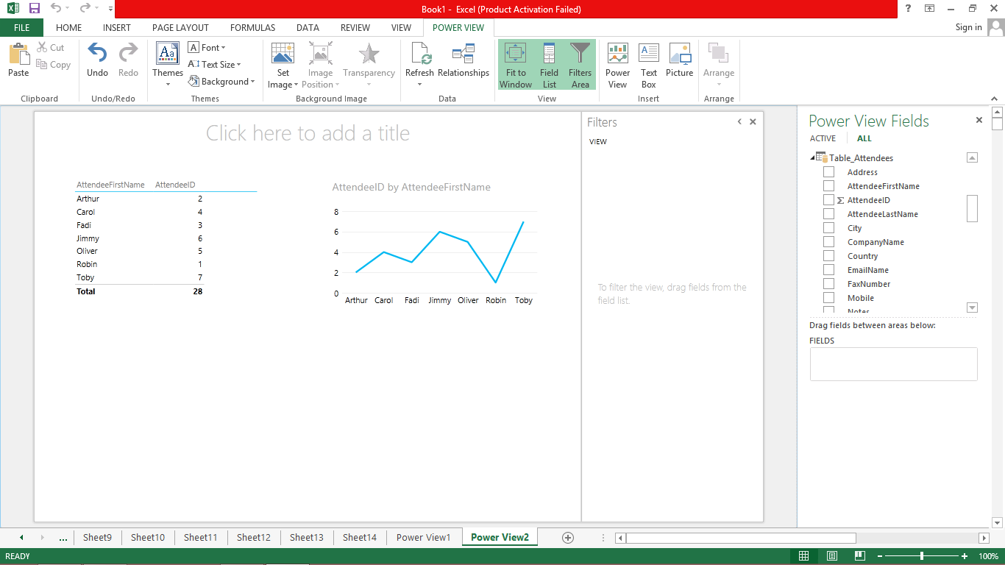

In a Bar Chart, categories are organized along the vertical axis and values along the horizontal axis. In Power View, there are three subtypes of the Bar Chart: Stacked, 100% stacked, and Clustered.

[**Step 7** − Click on the Line Chart Visualization.](https://e-next.in/)

[**Step 8** − Click on Bar Chart in the Switch Visualization Group.](https://e-next.in/)

[**Step 9** − Click on the Stacked Bar option.](https://e-next.in/)

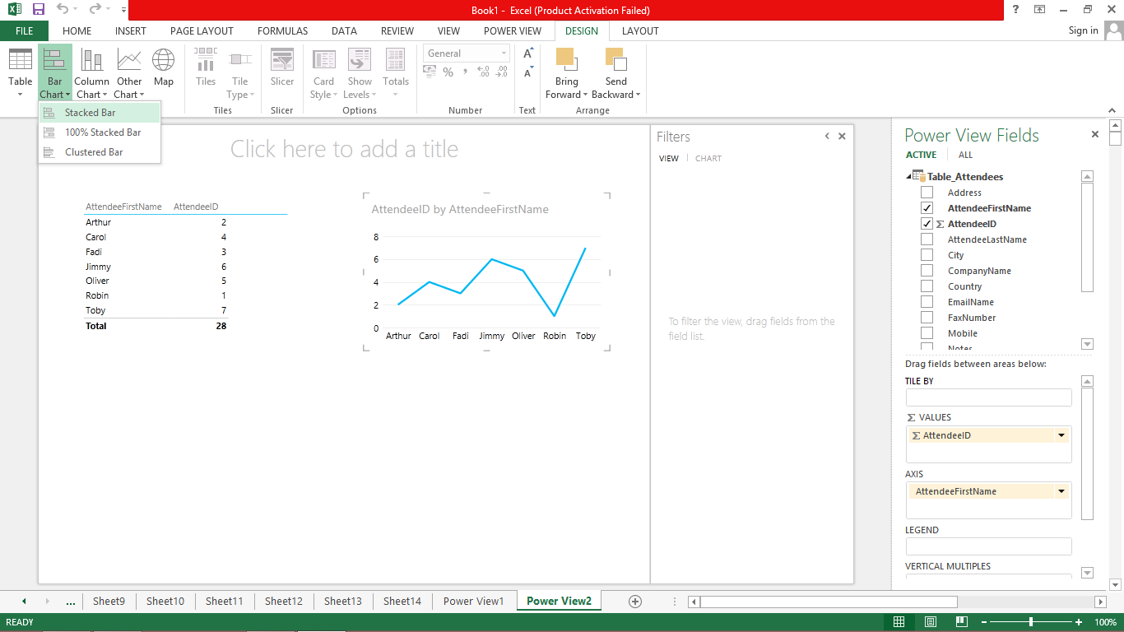

The Line Chart Visualization converts into Stacked Bar Chart Visualization.

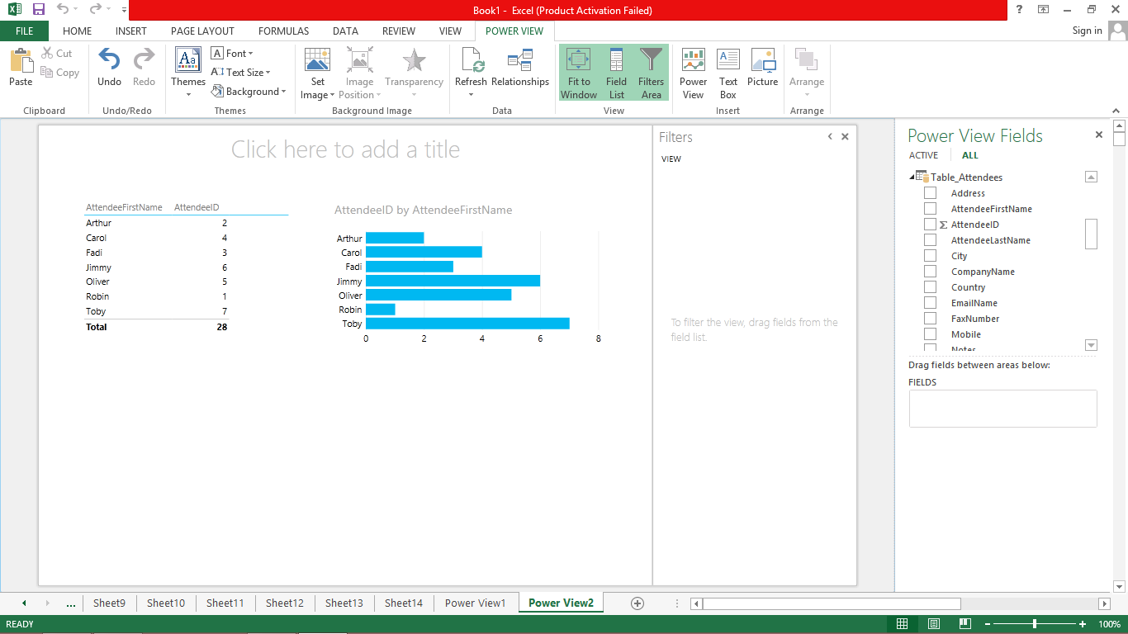

**Step 10** − In the Power View Fields, in the Attendees Table, select the Field Country also.

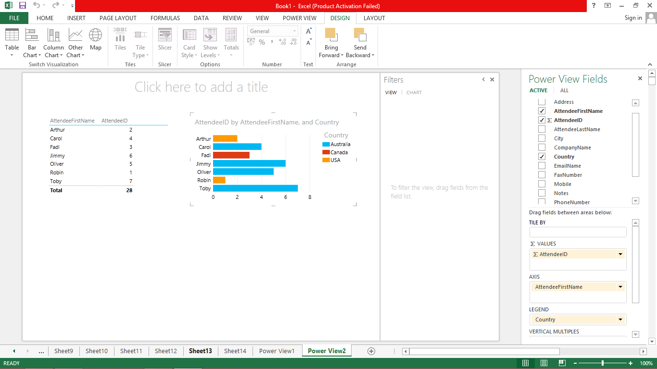

**Step 11** − Click on one of the bars. That portion of the bar is highlighted. Only the row containing the Data specific to the selected bar is displayed in the table above.

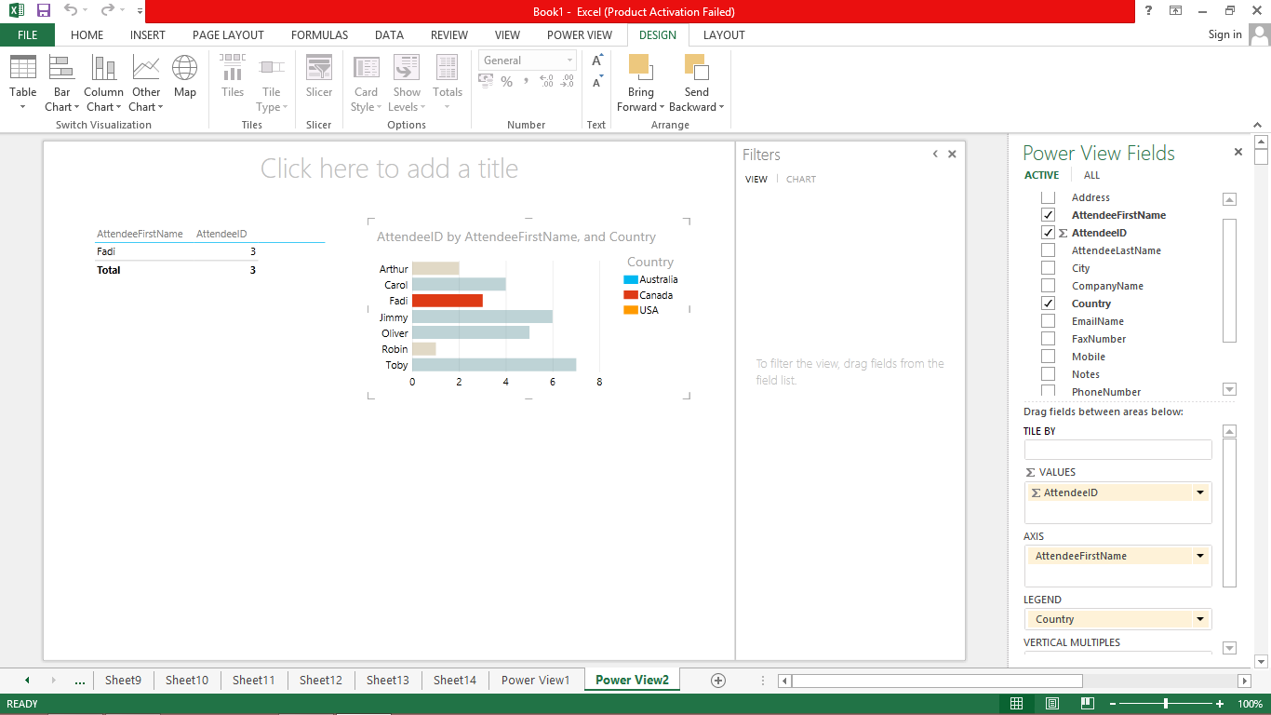

[In Power View, there are three Column Chart subtypes: Stacked, 100% stacked, and Clustered.](https://e-next.in/)

[**Step 12** − Click on the Stacked Bar Chart Visualization.](https://e-next.in/)

[**Step 13** − Click on Column Chart in the Switch Visualization group.](https://e-next.in/)

[**Step 14** − Click on Stacked Column.](https://e-next.in/)

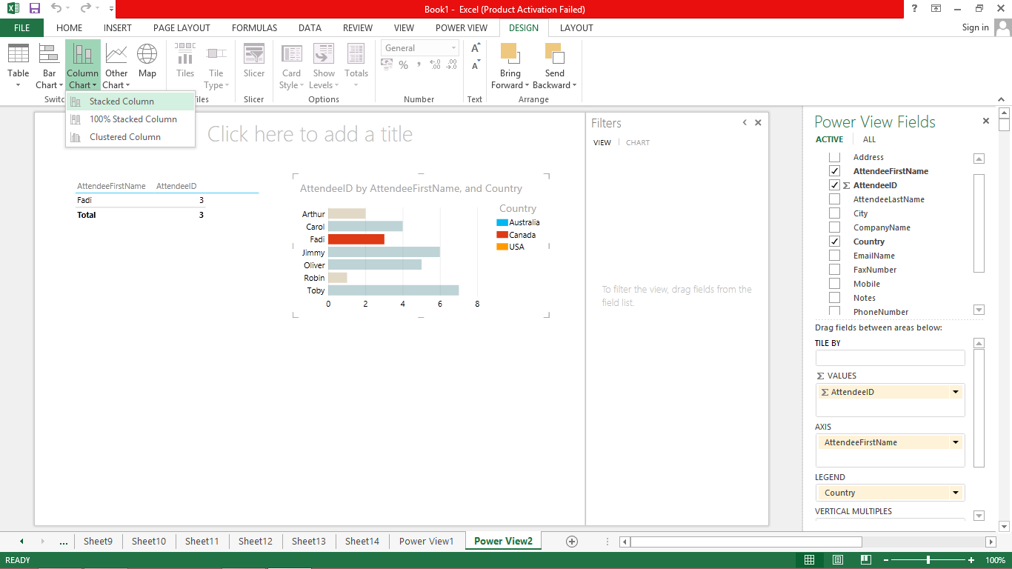

The Stacked Bar Chart Visualization converts into Stacked Column Chart Visualization.

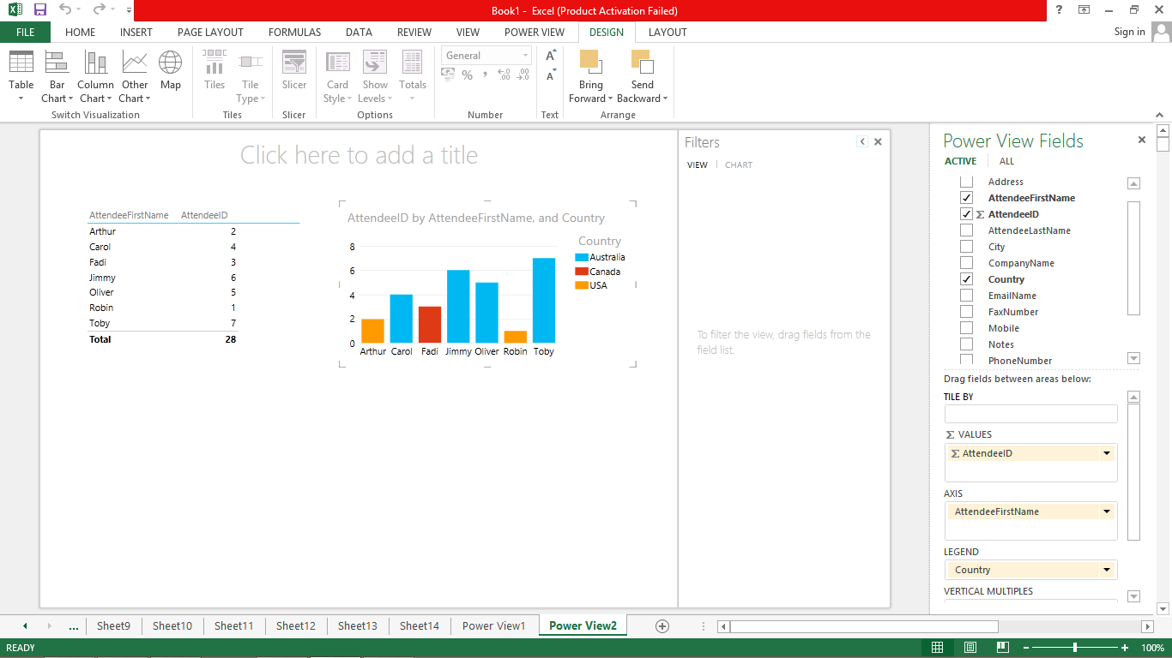

You can have simple Pie Chart Visualizations in Power View.

**Step 1** − Click on the Table Visualization as shown below.

[**Step 2** − Click on Other Chart in the Switch Visualization group.](https://e-next.in/)

[**Step 3** − Click on Pie as shown in the image given below.](https://e-next.in/)

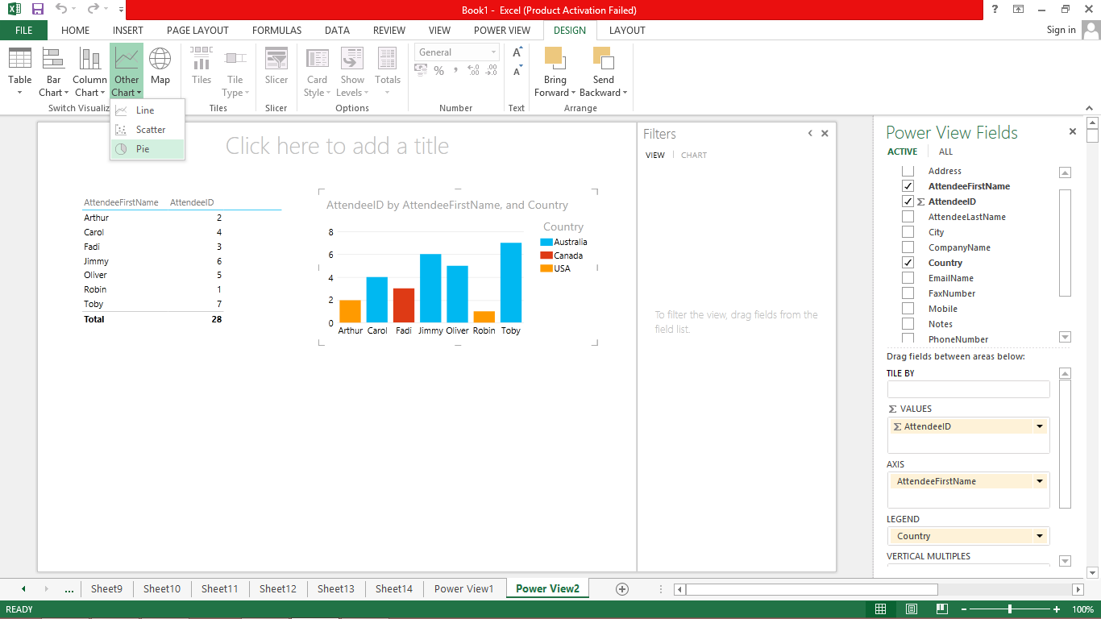

The Stacked Column Chart Visualization converts into Pie Chart Visualization.

